QCT Pilot Analysis

Tim Vigers

19 October 2018

Table 1a: Pearson correlations of pQCT and QCT measures with cortical area and thickness.

|  |  |  |  |  |  |  |  |  |
| --- | --- | --- | --- | --- | --- | --- | --- | --- |
|  | crt_thk_r33 | crt_thk_t38 | crt_thk_t66 | crt_a_r4 | crt_a_r33 | crt_a_t4 | crt_a_t38 | crt_a_t66 |
| average.cortical.thickness | 0.35 | 0.59 | **0.92** | -0.53 | 0.05 | -0.45 | 0.12 | 0.83 |
| cortical.area | 0.13 | 0.6 | 0.72 | -0.21 | -0.01 | -0.3 | 0.3 | 0.79 |
|  |  |  |  |  |  |  |  |  |

Table 1b: Unadjusted P-values for correlations of pQCT and QCT measures with cortical area and thickness.

|  |  |  |  |  |  |  |  |  |
| --- | --- | --- | --- | --- | --- | --- | --- | --- |
|  | crt_thk_r33 | crt_thk_t38 | crt_thk_t66 | crt_a_r4 | crt_a_r33 | crt_a_t4 | crt_a_t38 | crt_a_t66 |
| average.cortical.thickness | 0.57 | 0.29 | **0.03** | 0.36 | 0.94 | 0.44 | 0.84 | 0.08 |
| cortical.area | 0.83 | 0.28 | 0.17 | 0.73 | 0.98 | 0.63 | 0.63 | 0.12 |
|  |  |  |  |  |  |  |  |  |

Table 2a: Pearson correlations of pQCT and QCT measures cortical vBMD.

|  |  |  |  |
| --- | --- | --- | --- |
|  | crt_den_t4 | crt_den_r33 | crt_den_t38 |
| average.cortical.bmd | 0.14 | -0.57 | -0.33 |
| neck.cortical.bmd | -0.81 | -0.13 | -0.2 |
| troch.cortical.bmd | -0.88 | -0.61 | -0.61 |
| intertroch.cortical.bmd | -0.13 | 0.67 | 0.51 |
| total.hip.cortical.bmd | -0.56 | 0.27 | 0.15 |
|  |  |  |  |

Table 2b: Unadjusted P-values for correlations of pQCT and QCT measures cortical vBMD

|  |  |  |  |
| --- | --- | --- | --- |
|  | crt_den_t4 | crt_den_r33 | crt_den_t38 |
| average.cortical.bmd | 0.83 | 0.32 | 0.59 |
| neck.cortical.bmd | 0.1 | 0.84 | 0.75 |
| troch.cortical.bmd | 0.05 | 0.27 | 0.28 |
| intertroch.cortical.bmd | 0.84 | 0.22 | 0.38 |
| total.hip.cortical.bmd | 0.32 | 0.66 | 0.81 |
|  |  |  |  |

Table 3a: Pearson correlations of total density (vBMD) measures for pQCT and QCT.

|  |  |  |
| --- | --- | --- |
|  | tot_den_r4 | tot_den_t4 |
| total.bmd | 0.46 | 0.73 |
| l1bmd | -0.23 | 0.47 |
| l2bmd | -0.37 | 0.25 |
| neck.integral.bmd | 0.55 | 0.76 |
| avglumbarvbmd | -0.3 | 0.36 |
| troch.integral.bmd | 0.37 | 0.87 |
| intertroch.integral.bmd | 0.72 | **0.96** |
| total.hip.integral.bmd | 0.6 | **0.96** |
|  |  |  |

Table 3b: Unadjusted P-values for correlations of total density (vBMD) measures for pQCT and QCT

|  |  |  |
| --- | --- | --- |
|  | tot_den_r4 | tot_den_t4 |
| total.bmd | 0.44 | 0.16 |
| l1bmd | 0.72 | 0.42 |
| l2bmd | 0.54 | 0.68 |
| neck.integral.bmd | 0.34 | 0.14 |
| avglumbarvbmd | 0.62 | 0.55 |
| troch.integral.bmd | 0.55 | 0.05 |
| intertroch.integral.bmd | 0.17 | **0.01** |
| total.hip.integral.bmd | 0.29 | **0.01** |
|  |  |  |

Figure 1: Correlogram of pQCT and QCT measures with cortical area and thickness.

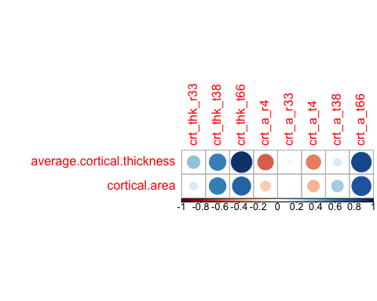

Figure 2: Correlogram of pQCT and QCT measures cortical vBMD.

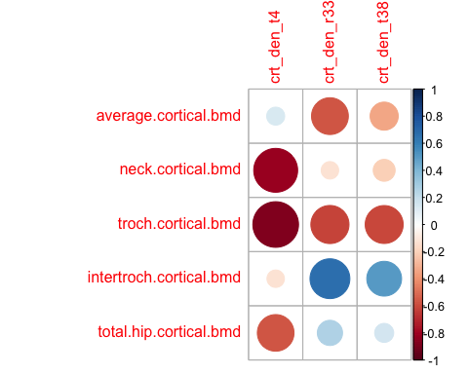

Figure 3: Correlogram of total density (vBMD) measures for pQCT and QCT.

